Q1.
Problem Statement

In a busy airport, passengers are holding tickets with unique numbers.

Write a program using the linear search algorithm to check if a given ticket number exists in the array of ticket numbers.

If the ticket number is found, print a congratulatory message along with the position where it's found. If the ticket number is not found, encourage the passenger with a message for better luck on the next attempt.
Input Format
The first line of input consists of an integer N, representing the number of tickets.
The second line consists of N space-separated integers, representing the ticket numbers.
The third line consists of an integer X, representing the ticket number to search.
Output Format
If the ticket number is found, print "Congratulations! Ticket number X found at position Y!", where X is the ticket number and Y is the position (position starts from 1).
Otherwise, print "Better luck next time! Ticket number X not found!", where X is the ticket number.

Refer to the sample output for formatting specifications.
Constraints
1 ≤ N ≤ 10
10 ≤ ticket number, X ≤ 1000
Sample Input Sample Output
5
123 456 789 321 654
321
Congratulations! Ticket number 321 found at position 4!
Sample Input Sample Output
6
741 456 982 364 789 258
369
Better luck next time! Ticket number 369 not found!
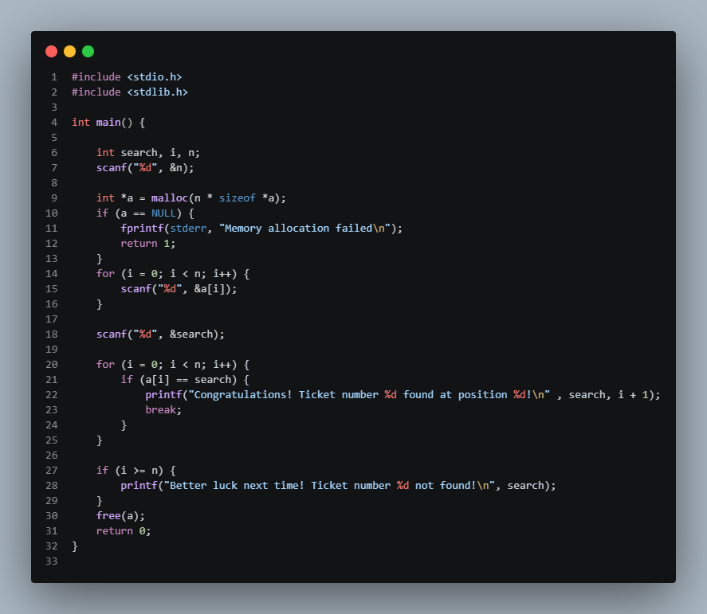
Q2.
Problem Statement

You are working as a data analyst for a company that collects user feedback scores for their products. The feedback scores are recorded sequentially, and sometimes you need to identify specific feedback points for analysis.

Given a list of feedback scores and a particular feedback score, your task is to find the position of the second occurrence of this feedback score in the list. If the feedback score appears less than twice, you need to handle that as well:

- If the feedback score does not appear at all, print a message indicating that the score was not found.
- If the feedback score appears only once, print a message indicating that the score was found only once.
- If the feedback score appears more than once, print the position (index) of the second occurrence.
Input Format
The first input line contains an integer n, the number of feedback scores.
The second input line contains n space-separated integers, each representing a feedback score.
The third input line contains an integer X, which is the feedback score you need to find the second occurrence of.
Output Format
The output displays the following format:
- The position of the second occurrence of the key in the list, or:
- "X Score not found." if the score is not present in the list, or:
- "X Score found only once." if the score appears only once.

Refer to the sample output for formatting specifications.
Constraints
1 ≤ N ≤ 10
0 ≤ score, K ≤ 100

Sample Input Sample Output
5
45 56 98 56 32
56
3
Sample Input Sample Output
4
71 52 63 94
89
89 Score not found.
Sample Input Sample Output
4
85 96 32 45
45
45 Score found only once.

Q3.
Problem Statement

In a local election, each candidate is assigned a unique numeric ID. After collecting the votes, you need to determine if any candidate received more than n−2 votes, where n is the total number of votes cast. This will help in identifying if there is a clear winner with significant support.

Your task is to write a program that determines if there is a candidate ID that received more than n−2 votes. If such a candidate exists, return their ID. Otherwise, return "No majority candidate found."
Input Format
The first line contains an integer n — the total number of votes cast.
The second line contains n space-separated integers, each representing the candidate ID for each vote.
Output Format
The output displays the following format:
If a candidate received more than n−2 votes, output their ID.
If no candidate meets this criterion, output "No majority candidate found."

Refer to the sample output for formatting specifications.
Constraints
1 ≤ n ≤ 10
1 ≤ candidate ID ≤ 100
Sample Input Sample Output
5
1 4 1 1 1
1
Sample Input Sample Output
8
12 12 12 12 13 12 12 12
12
Sample Input Sample Output
5
56 58 45 54 55
No majority candidate found.

Q4.
Problem Statement

You are part of a legal team responsible for reviewing contracts and legal documents. To streamline the review process, you need a tool that can quickly check if specific legal terms or clauses are included in a large text document. This tool helps ensure that essential terms are not overlooked.

Write a program that searches a given document (a sentence) for the presence of a specific legal term or clause. The tool should indicate whether the term is present in the document.
Input Format
The first line consists of a string S, the document (a single sentence) containing up to 1000 characters.
The second line consists of a string T, representing the legal term or clause to search for, which can be up to 100 characters long.
Output Format
The output displays the following format:
If the legal term or clause is found in the document, output: The word 'T' is present in the given sentence.
If the legal term or clause is not found, output: The word 'T' is not present in the given sentence.

Refer to the sample output for formatting specifications.
Constraints
1 ≤ length of S ≤ 999
1 ≤ length of T ≤ 99
The input sentence is case-sensitive.
Sample Input Sample Output
Constellations of stars, murals on city walls
stars
The word 'stars' is present in the given sentence.
Sample Input Sample Output
Constellations of Stars, murals on city walls
stars
The word 'stars' is not present in the given sentence.

Q5.
Problem Statement

In a warehouse, inventory management requires checking the availability of specific items in stock. Each item in the inventory is identified by a unique numerical ID. Given a list of items currently in the warehouse and a set of item IDs that need to be checked, determine if each item ID from the set is present in the warehouse inventory and identify its position if it is available.

Implement a tool that reads the inventory IDs, followed by a list of item IDs to be checked, and then performs a search to determine if each item ID is present in the inventory. For each item ID, output its position in the inventory if found, or indicate that the item is not available.
Input Format
The first line contains an integer n1, representing the number of items in the warehouse inventory.
The second line contains n1 space-separated integers, representing the IDs of the items in the warehouse inventory.
The third line contains an integer n2, representing the number of item IDs to be checked.
The fourth line contains n2 space-separated integers, representing the item IDs that need to be checked.
Output Format
The output displays for each item ID in the checklist, separated by a line:

If the item ID is found in the inventory, output the item ID followed by its position (1-based index) in the inventory.
If the item ID is not found in the inventory, output the item ID followed by "not found in the inventory".

Refer to the sample outputs for format specifications.
Constraints
1 ≤ n1 n2 ≤ 10
The index starts at 1.
Sample Input Sample Output
5
10 20 30 40 50
4
20 30 40 60
20 found at position 2
30 found at position 3
40 found at position 4
60 not found in the inventory
Sample Input Sample Output
4
11 22 33 44
2
22 55
22 found at position 2
55 not found in the inventory

Q6.
Problem Statement

In a company's customer service center, each customer interaction is logged with a unique numerical ID. A customer support representative needs to search through these logs to find the position of a specific customer interaction ID and also analyze the overall interaction data.

Implement a tool to search for a specific customer interaction ID in a log of interaction IDs, determine its position if it exists, and report the total number of comparisons made during the search. Additionally, calculate and display the total number of interactions and the average number of interactions per ID.
Input Format
The first line contains an integer n, representing the number of customer interactions recorded.
The second line contains n integers, each representing the unique interaction ID recorded.
The third line contains an integer x, representing the interaction ID to be searched.
Output Format
The output displays the following format:
- Print an integer the position (0-based index) of the interaction ID x if found. If not found, print a message stating that the interaction ID x is not present.
- Print an integer the total number of comparisons made during the search process, prefixed by "Total comparisons made: ".
- Print an integer the total sum of all interaction IDs, prefixed by "Sum of all interaction: ".
- Print double value the average of all interaction IDs, prefixed by "Average of all interaction: ".

Refer to the sample output for formatting specifications.
Constraints
1 ≤ n ≤ 10
1 ≤ interaction ID ≤ 10⁴
Sample Input Sample Output
5
40 20 50 30 10
30
Interaction ID 30 is present at index 3
Total comparisons made: 4
Sum of all interaction: 150
Average of all interaction: 30.00
Sample Input Sample Output
5
40 20 50 30 10
80
Interaction ID 80 is not present
Total comparisons made: 5
Sum of all interaction: 150
Average of all interaction: 30.00

Q7.
Problem Statement

Sathish is developing a simple inventory management system for a store. The store owner wants to update the stock levels of certain products based on the latest shipment.

Write a program that takes the current stock levels as input, along with the product code to search for and the new quantity received. Implement a linear search program to find the product in the inventory and update its stock with the new quantity.

Finally, print the updated inventory after the stock update.
Input Format
The first line consists of an integer N, representing the size of the inventory.
The second line consists of N space-separated integers, representing the current stock levels.
The third line consists of an integer X, representing the product code to search for.
The fourth line consists of an integer M, representing the new quantity received.
Output Format
The output prints the updated array with the X replaced by M. Elements should be separated by a space.
If the X is not found in the array, the output will be the same as the original array since no replacements are made.

Refer to the sample output for formatting specifications.
Constraints
1 ≤ N ≤ 10
10 ≤ stock level ≤ 100
10 ≤ M ≤ 100
Sample Input Sample Output
5
45 56 78 89 65
78
85
45 56 85 89 65
Sample Input Sample Output
8
73 91 45 67 98 36 22 49
73
75
75 91 45 67 98 36 22 49
Sample Input Sample Output
4
76 54 23 46
87
78
76 54 23 46

Q8.
Problem Statement

In a manufacturing plant, quality control inspectors need to verify that all parts on a production line meet specific quality standards. Each part is assigned an ID number, and for the parts to be approved, all IDs must be even numbers.

Your task is to develop a tool that helps in checking whether all parts in a batch meet this requirement.

Given a list of part IDs, determine if every ID in the list is an even number. If all IDs are even, report that the batch is approved; otherwise, report that the batch is not approved.

Company Tags: DXC and TCS.
Input Format
The first line of input consists of an integer N, representing the list size.
The second line consists of N space-separated integers, representing the list of part IDs.
Output Format
The output displays the following format:

If all IDs are even, print: "All parts in the batch are approved."
Otherwise, print: "The batch is not approved."

Refer to the sample output for formatting specifications.
Constraints
1 ≤ N ≤ 10
1 ≤ part ID ≤ 100
Sample Input Sample Output
5
12 18 24 16 38
All parts in the batch are approved.
Sample Input Sample Output
3
15 26 39
The batch is not approved.

Q9.
Problem Statement

Alex, a logistics manager, is responsible for handling various pieces of luggage. He needs to determine the weight distribution among these pieces and find the heaviest and lightest pieces, along with the weight difference between them.

To accomplish this, he plans to create a simple program that takes as input the weights of various pieces of luggage and uses the linear search algorithm to search and identify the heaviest and lightest pieces, as well as calculate the weight difference between them.

Write a program to help Alex accomplish this task.
Input Format
The first line consists of an integer N, representing the number of luggage.
The second line consists of N space-separated integers, representing the weights of the luggage.
Output Format
The first line of output prints "Heaviest piece weight: " followed by the weight of the heaviest piece.
The second line prints "Lightest piece weight: " followed by the weight of the lightest piece.
The third line prints "Weight difference: " followed by their weight difference.

Refer to the sample output for formatting specifications.
Constraints
The test cases fall under the following constraints:
1 ≤ N ≤ 10
1 ≤ weight of each piece ≤ 100
Sample Input Sample Output
5
10 15 20 25 30
Heaviest piece weight: 30
Lightest piece weight: 10
Weight difference: 20
Sample Input Sample Output
8
70 65 80 75 60 55 50 45
Heaviest piece weight: 80
Lightest piece weight: 45
Weight difference: 35

Q10.
Problem Statement

In a research lab specializing in data collection, the team frequently deals with large datasets where quick lookup and data reversal are crucial.

The team needs to ensure that certain data points (identified by unique IDs) are present in their datasets and also needs to analyze data trends by reversing the order of the collected data.
Input Format
The first line consists of an integer N representing the number of data points in the dataset.
The second line consists of the list of N integers representing the data points.
The third line consists of an integer x that represents the data point to be searched for in the dataset.
Output Format
The first line displays "Data point isn't present in the dataset" if the data point x is not found in the dataset. Otherwise, print "Data point is present in the dataset at position [index]" where index is the 0-based index of the data point in the dataset.
The second line displays the reversed dataset, with each data point separated by a space.

Refer to the sample output for formatting specifications.
Constraints
1 ≤ N ≤ 10
0 ≤ elements, x ≤ 100
Sample Input Sample Output
5
45 56 98 97 32
56
Data point is present in the dataset at position 1
32 97 98 56 45
Sample Input Sample Output
4
71 52 63 94
89
Data point isn't present in the dataset
94 63 52 71

Q11.
Problem Statement

In a large-scale sales database, the management team is tasked with performing critical data analysis to ensure optimal business decisions. The database contains records of sales amounts for various transactions. For strategic planning, the team needs to:

- Quickly check if a particular sales amount has been recorded and, if so, identify its position in the dataset.
- To understand competitive performance and identify the second-best sales figures, which may be crucial for benchmarking and incentive planning.
Input Format
The first line consists of an integer N representing the number of transactions.
The second line consists of the list of N integers representing the sales amounts.
The third line consists of an integer x representing the sales amount to search for in the dataset.
Output Format
The output is displayed in the following format:

If the sales amount x is found in the array, print a message in the format:
"Sales amount x is recorded at position <pos>", where <pos> is the 1-based index of the sales amount in the dataset.

If the sales amount x is not found, print a message in the format:
"Sales amount x is not recorded in the dataset".

The second-highest sales amount in the dataset. If no second-highest amount exists, print:
"No second highest sales amount found".

Refer to the sample output for the formatting specifications.
Constraints
1 ≤ n ≤ 100
1 ≤ sales amount ≤ 100
1 ≤ x ≤ 100
Sample Input Sample Output
5
19 15 24 43 37
24
Sales amount 24 is recorded at position 3
37
Sample Input Sample Output
5
19 15 24 43 37
16
Sales amount 16 is not recorded in the dataset
37
Sample Input Sample Output
1
2
3
Sales amount 3 is not recorded in the dataset
No second highest sales amount found

Q12.
Arsh is working on enhancing a recommendation system for a shopping application. He needs to develop a feature that suggests the closest product prices to a target price entered by a user. The list of product prices is sorted in non-decreasing order, and he wants the system to find the K closest prices to the target price. If two prices have the same difference from the target, the lower price should be preferred.

To implement this feature, Arsh needs to write a program that identifies and prints the K closest prices to the given target price from the sorted list of prices. If there are two prices with the same difference value, print the larger price.

Example

Input:
5
2 4 7 8 10
5
3
Output:
4 7 8

Explanation
The closest crossover point for x = 5 is at index 1 (element 4).
Compare differences: 4 (|5-4|=1), 7 (|7-5|=2), 8 (|8-5|=3).
Closest k=3 elements are 4, 7, 8 based on proximity to x=5.
Input Format
The first line contains an integer n, representing the number of product prices.
The second line contains n space-separated integers, representing the sorted product prices.
The third line contains an integer x, denoting the target price.
The fourth line contains an integer k, representing the number of closest prices to find.
Output Format
The output displays k space-separated integers representing the k closest prices to the target value.

Refer to the sample output for the formatting specifications.
Constraints
1 ≤ n ≤ 10
1 ≤ product prices ≤ 100
Prices are given in ascending order.
1 ≤ k ≤ n
Sample Input Sample Output
5
2 4 7 8 10
5
3
4 7 8
Sample Input Sample Output
8
1 3 5 7 9 11 13 15
10
1
11

Q13.
You are in charge of preparing a series of meals for a special event. Each meal needs to be cooked using ingredients from a set of ingredient boxes. Each box becomes available on a specific day, and you need to cook a certain number of meals using the ingredients from adjacent boxes.

You are given an integer array availabilityDay, an integer m, and an integer k.

- availabilityDay[i] represents the day when the i-th ingredient box becomes available.
- To prepare one meal, you need to use k adjacent ingredient boxes.
- You need to prepare m meals.

Your task is to find the minimum number of days you need to wait to be able to prepare m meals using the available ingredient boxes. If it's impossible to prepare the required number of meals, return -1. Implement the problem using recursive binary search.

Example 1

Input:
5
1 10 3 10 2
3
1

Output:
3

Explanation:
You need to prepare 3 dishes, each needing 1 box of ingredients. The boxes become available on different days:
Day 1: [x, _, _, _, _] - 1 dish possible.
Day 2: [x, _, _, _, x] - 2 dishes possible.
Day 3: [x, _, x, _, x] - 3 dishes possible.
The minimum number of days required is 3.

Example 2

Input:
5
1 10 3 10 2
3
2

Output:
-1

Explanation:
You need to prepare 3 dishes, each requiring 2 boxes of ingredients. To make 3 dishes, you need a total of 6 boxes. Since there are only 5 boxes available, it is impossible to prepare all 3 dishes. Therefore, the output is -1.
Input Format
The first line contains an integer n, representing the number of ingredient boxes.
The second line contains n space-separated integers, representing the days when each ingredient box becomes available.
The third line contains an integer m, representing the number of meals needed.
The fourth line contains an integer k, representing the number of adjacent ingredient boxes required for one meal.
Output Format
The output prints the minimum number of days required to be able to prepare m meals, or -1 if it is not possible.

Refer to the sample output for formatting specifications.
Constraints
1 ≤ n ≤ 100
1 ≤ m ≤ 100
1 ≤ k ≤ n
Sample Input Sample Output
5
1 10 3 10 2
3
1
3
Sample Input Sample Output
5
1 10 3 10 2
3
2
-1
Sample Input Sample Output
7
7 7 7 7 12 7 7
2
3
12

Q.14
You are part of a team managing an amusement park with several rides, each identified by a unique ride ID. These ride IDs are stored in a sorted list in ascending order. When a new ride is introduced or when the system needs to locate a ride, you need to find the correct position of the ride ID in the list.

If the ride ID already exists, return its position. If not, return the index where the new ride ID should be inserted to maintain the order.
Input Format
The first line contains an integer n, representing the number of existing ride IDs in the sorted list.
The second line contains n space-separated integers, representing the unique IDs of the rides in ascending order.
The third line contains an integer targetID, representing the ID of the new ride to be introduced or located.
Output Format
The output is a single integer representing the index where the targetID would be inserted in the sorted list of ride IDs to maintain the order.

Refer to the sample output for formatting specifications.
Constraints
1 ≤ n ≤ 100
1 ≤ unique IDs of the rides ≤ 100
1 ≤ targetID ≤ 100
Sample Input Sample Output
4
1 3 5 6
5
2
Sample Input Sample Output
4
1 3 5 6
2
1
Sample Input Sample Output
3
10 20 30
40
3
Sample Input Sample Output
3
10 20 40
1
0

Q15.
Problem Statement

You are working as a software developer at a financial analytics company. The company provides tools for various financial analyses, including computing statistics on sets of data.

Today, you are assigned to enhance a tool that calculates the median of two datasets. These datasets represent financial transactions recorded over different periods. Your task is to develop a feature that finds the median of the combined data, which helps in understanding the central tendency of transaction amounts over time.
Input Format
The first line contains the number of data points in the first dataset.
The second line contains the data points of the first dataset in sorted order.
The third line contains the number of data points in the second dataset.
The fourth line contains the data points of the second dataset in sorted order.
Output Format
The output prints the median of the combined datasets, as a float value rounded to two decimal places.

Refer to the sample output for formatting specifications.
Constraints
1 ≤ number of data points in the first dataset ≤ 10
1 ≤ number of data points in the second dataset ≤ 10
1 ≤ data points ≤ 100
Sample Input Sample Output
3
10 20 30
2
10 20
20.00
Sample Input Sample Output
5
1 2 3 4 5
2
6 7
4.00
Sample Input Sample Output
3
54 87 90
1
67
77.00

